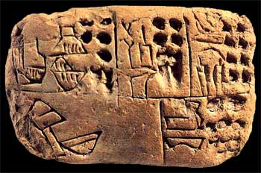
IT’S ALL GREEK TO ME!
Carlos of Coronado
2015

(01) birth of the titans (16) aeolus
(02) windchimes of change (17) pythia of delphi
(03) mt. olympus a distance away (18) eurydice
(04) cronus (19) orpheus
(05) birth of the Olympians (20) paris seduces helen
(06) furies wrath (21) one thousand ships
(07) zeus jamming (22) dream of paris
(08) hera suffering (23) death of achilles
(09) satyrs dancing (24) patient penelope
(10) rapture of the maenad (25) ulysess travels
(11) dancing muse (26) dawn at ithaca
(12) seven sisters (27) searching for peace but only finding fun
(13) voices of asphodel (28) three hundred march to die
(14) pershepone (29) boatman
(15) medusa (30) it’s only greek to me

A multi-part journey from the primordial nothingness to the Spartans. This is a DVD-A(udio) which will work in DVD players and has chapter points.
The entire work is over two and one half hours. Composed and created with computers and software by Carlos of Coronado, 2015.

